Tutorial 1: General

1. Why does the upper horizontal line appear longer despite the fact that the 2 horizontal lines are equal in length?
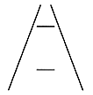
2. Using homogenous coordinates compute the intersection of the two lines in the plane defined by the equations (5x + 8y –12=0) and (-3x + 4y+2=0). Now compute the intersection between the two lines defined by (2x + 3y – 10 = 0) and (-4x - 6y + 2 = 0). Comment on your results. Similarly give the equations for the line (in terms of homogeneous coordinates) that passes between the points (5, -3) and (-6, 12) and the line between (2, -9) and (2, 10).

3. A simplified image of a railway track and the horizon is given by three lines represented in homogeneous dual coordinates as
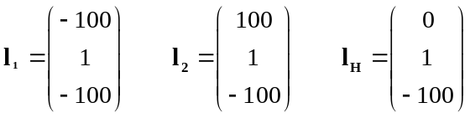
Sketch the image. What does the intersection of l₁ and l₂ correspond to in reality? Such points are called the vanishing points. Which object points does the horizon line l_{H} correspond to in reality?

4.

A scaled orthographic projection is an orthographic projection
followed by isotropic scaling.

x=kX, y=kY
If the world point (X,Y,Z) and image point (x,y) are represented by homogeneous vectors, write down the matrix representing the linear mapping between their homogeneous coordinates.

5. The singular value decomposition of the matrix A is given by
A = 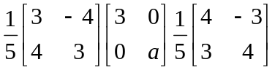
(a) Find solution x of the least square problem ||Ax-b|| = min with b=(1,2)^{T} for (i) a=10⁻³ and (ii) a=0 such that ||x|| is minimum norm.
(b) Find solution x of the least square problem ||Ax|| = min for a=0.

6. How can a 3D point at ∞ be described in homogeneous coordinates? Give the homogeneous coordinates of a 3D point at ∞ in the direction of the X-axis. Convert the homogeneous points [3 4 2 2]^{T} to inhomogeneous coordinates..

7. In projective plane P ² , a point is defined by three numbers x=(x,y,z) ^{T}. A line is also defined by a triplet of numbers l=(l₁,l_{2,} l₃) ^{T}. The equation of line is given by l^{T} x = 0. The point is called the dual to the line. Similarly in projective space P ³ , the dual to a point is a plane. You can see the similarity by looking at the plane equation. The world plane Π in 3D space is defined by n^{T}X=0 where X is any point on the plane, and n is the normal to the plane, with both X and n represented in homogeneous coordinates. Now assume that object points X are projected onto the image points x according to the camera projection equation x = PX, where P is the 3x4 projection matrix. As mentioned above, the constraint that the image point x lies on a line l can be written as

l^{T} x = 0

Insert the camera projection equation into this constraint. What constraint do we get on the object point X that project to points on the line? Interpret P^{T} l .

8. Explain the sources of depth information that arise from stationary, monocular cues in the image shown in the Figure below
